T



To solve:



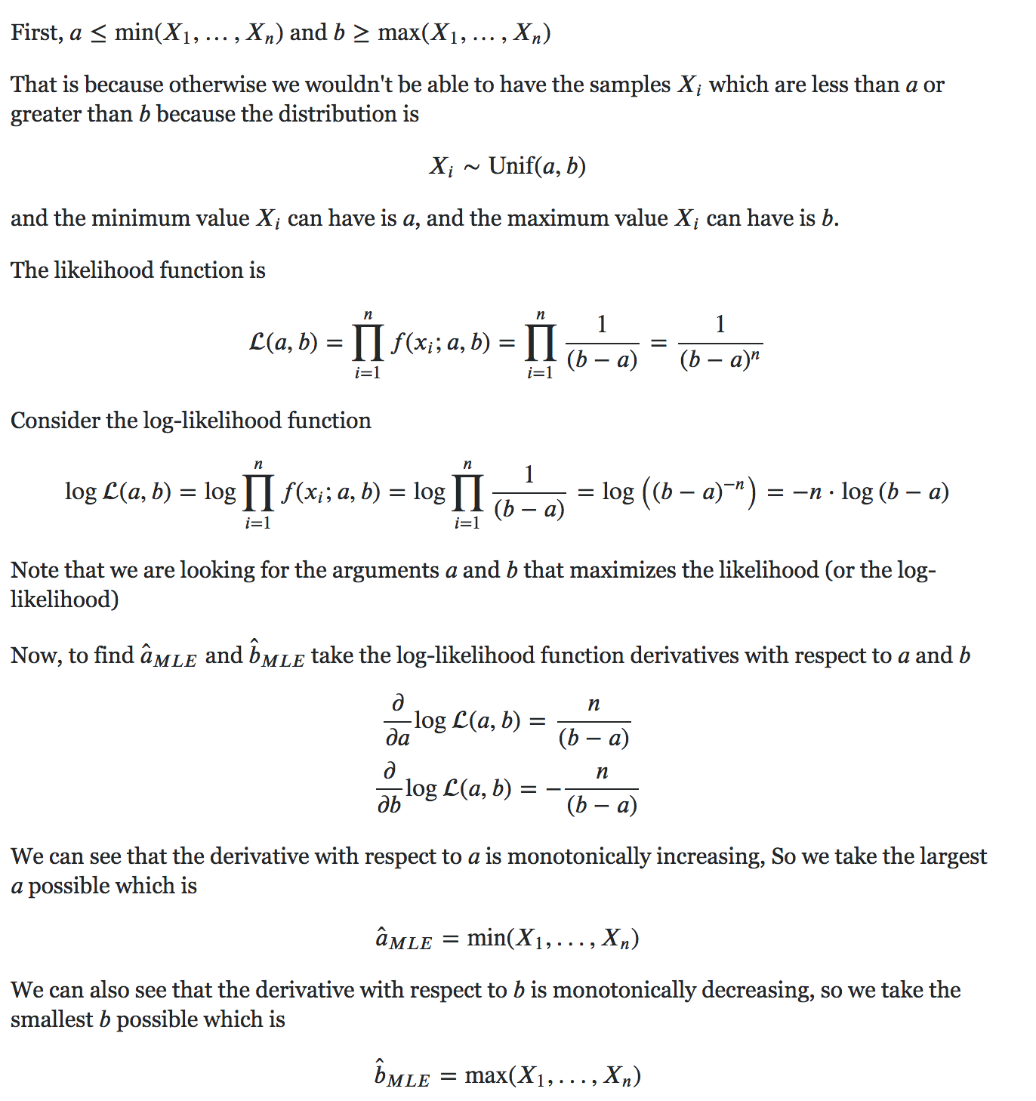

* 1. Sample mean = 35.98

Sn-1 = 15.24…

t8,0.995 = 3.36

sqrt(n) = 3

Use sample mean -/+ t8,0.995 * Sn-1 / sqrt(n)

[18.91, 53.05]

* 1. Null Hypothesis:

$$H_{0}:μ_{X}=μ_{Y}$$

Bias-corrected pooled sample variance ${S^{2}}_{n_{1}+n_{2}-2}=\frac{1}{2}*900+\frac{1}{2}*700=800$

Test statistic

$$T=\frac{\underline{X}-\underline{Y}}{S_{n_{1}+n_{2}-2}\sqrt{1/n_{1}+1/n_{2}}}=\frac{30}{\sqrt{800*2/11}}=2.4875$$

Rejection region at the 95% level :

$$R=\{t | \left|t\right| > t_{n_{1}+n_{2}-2,1-\frac{α}{2}}\}=\{t | \left|t\right| > t_{20,0.975}\} = \{t | \left|t\right| > 2.09\}$$

We can reject the null hypothesis.



Observed:

|  |  |  |  |
| --- | --- | --- | --- |
|  | **+** | **=** | **-** |
| **Labour** | 137 | 82 | 66 |
| **Conservative** | 63 | 66 | 86 |

Expected:

|  |  |  |  |
| --- | --- | --- | --- |
|  | **+** | **=** | **-** |
| **Labour** | 114 | 84.4 | 86.6 |
| **Conservative** | 86 | 63.6 | 65.4 |

$$χ^{2}=\sum{}\frac{(O-E)^{2}}{E}$$

22.38

V = (3-1)(2-1) = 2

X_2 <= 10.60 for sig level <= 0.5%

We reject null hypothesis at any reasonable sig level <=0.5%.

2)

i) mean = 572.8

Std Dev = **20.14**

b)

i)

exp(itX) = e^(itX)

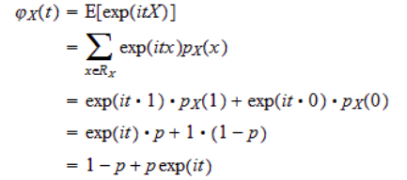

ii)

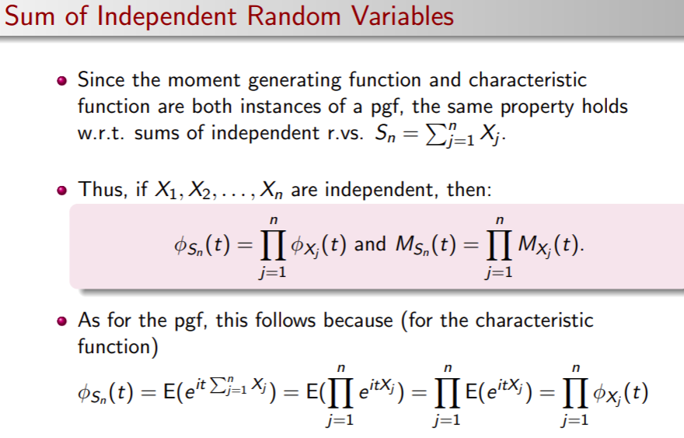

iii-v)

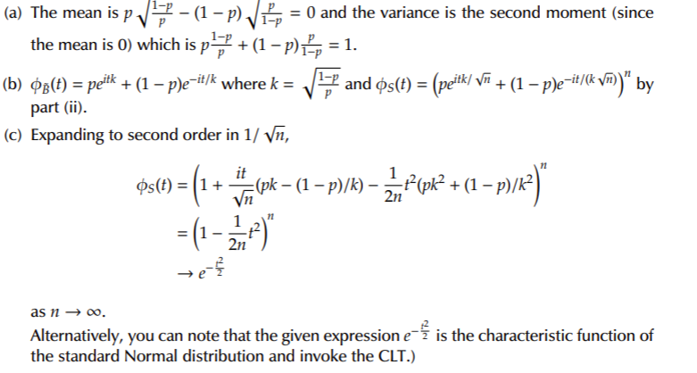

c)

Let’s see if Cunningham’s law holds.

Exercise sheet 4: 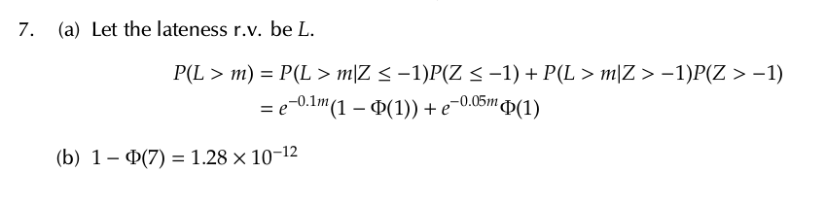

i)

We have Z~N(0,1), X~Exp(1/10), Y~Exp(1/20) since mean of exp is 1/λ=20.

Let A be a RV that says how late the professor is. By the law of total probability we have

$$P(A > m) = P(X>m | Z<-1)P(Z<-1) + P(Y>m|Z>-1)P(Z > -1)$$

Probability of X and Y are given under condition that Z is a specific value, so P(X|Z<-1)=P(X) and same for Y. Therefore the equation is

$$P(A > m) = P(X > m)P(Z < -1) + P(Y > m)P(Z > -1)$$

Now we compute values for P(Z)s and we get

$$P\left(A > m\right) = 0.159*P\left(X > m\right) +0.841* P\left(Y > m\right)=0.159*e^{-m/10}+0.841*e^{-m/20}$$

ii)

Probability that train arrives before 7:30 is $P(Z < -7)=Φ(-7)=1-Φ(7)=1.28*10^{-12}≈0$  
How about the professor?😔